**1 - ServiceNow Tutorial for Beginners | Introduction to ServiceNow**

**ServiceNow** is a cloud-based platform designed to streamline IT service management (ITSM) and other business processes. It allows users to develop and manage applications without requiring extensive coding knowledge.

**Services of ServiceNow** - It include IT Service Management (ITSM), HR Management, Governance, Risk, and Compliance (GRC), IT Asset Management, and Business Management. These services enable organizations to automate workflows, manage incidents, and ensure compliance with regulations.

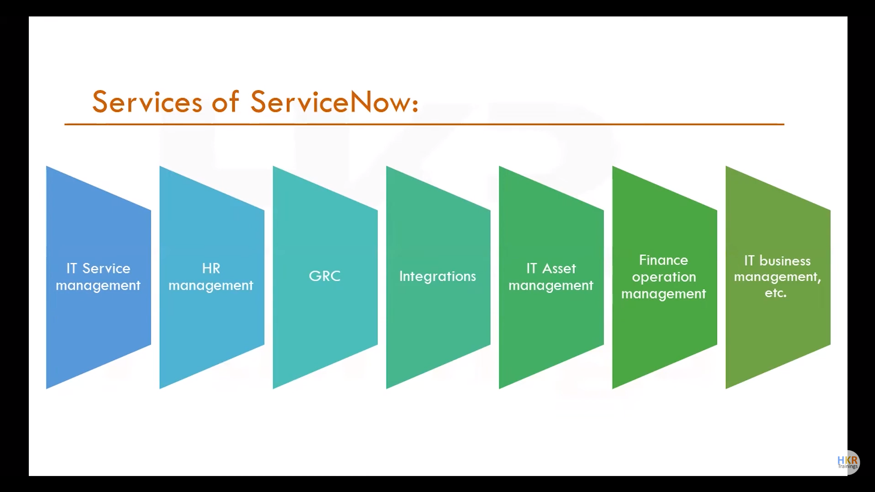

**How to Get Free ServiceNow Instances** - Free ServiceNow instances can be obtained by registering on the ServiceNow developer website. Users need to sign up, activate their accounts via email, and log in regularly to keep their instances active. Inactivity for more than ten days may require users to reclaim their instances.

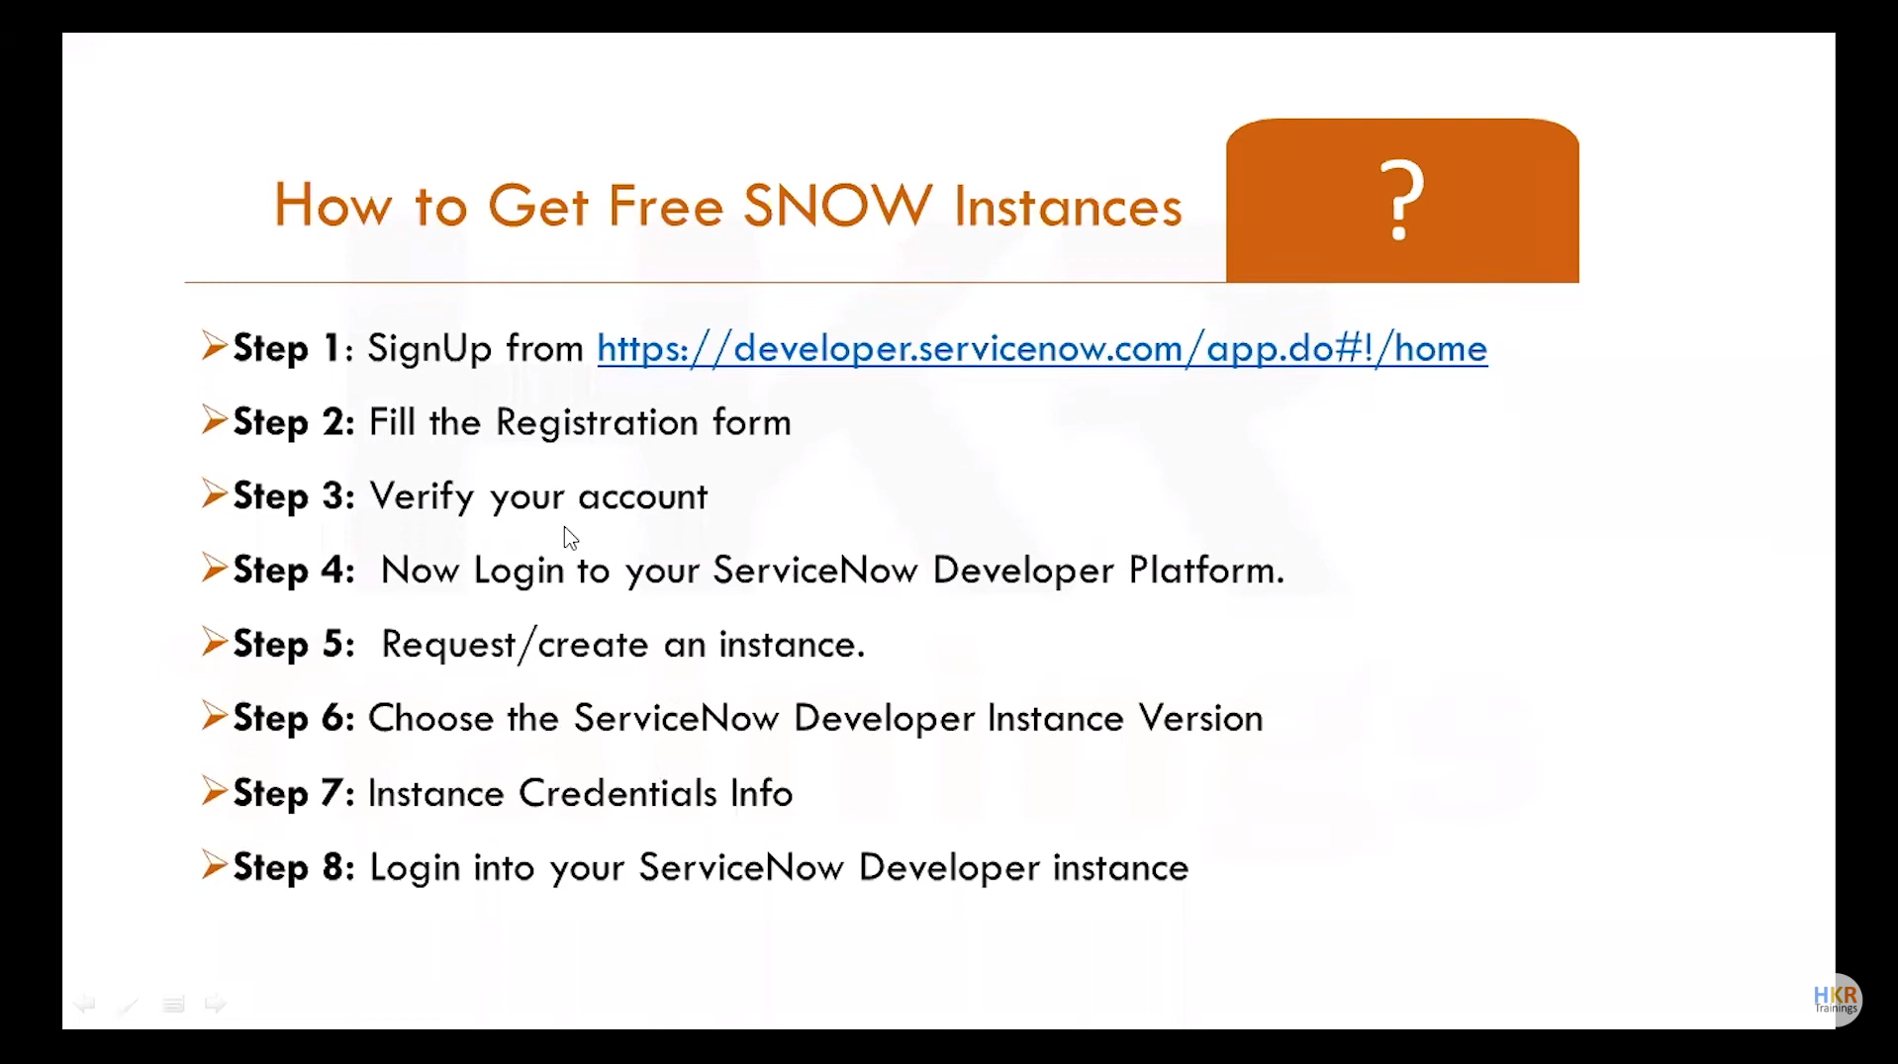

**How to Become a ServiceNow Developer** - Aspiring developers should ideally have a bachelor's degree and a basic understanding of JavaScript and ITIL. Completing a ServiceNow course and obtaining certifications such as the Certified System Administrator (CSA) is crucial. Non-IT backgrounds can also succeed by focusing on ServiceNow-specific scripting and development practices.

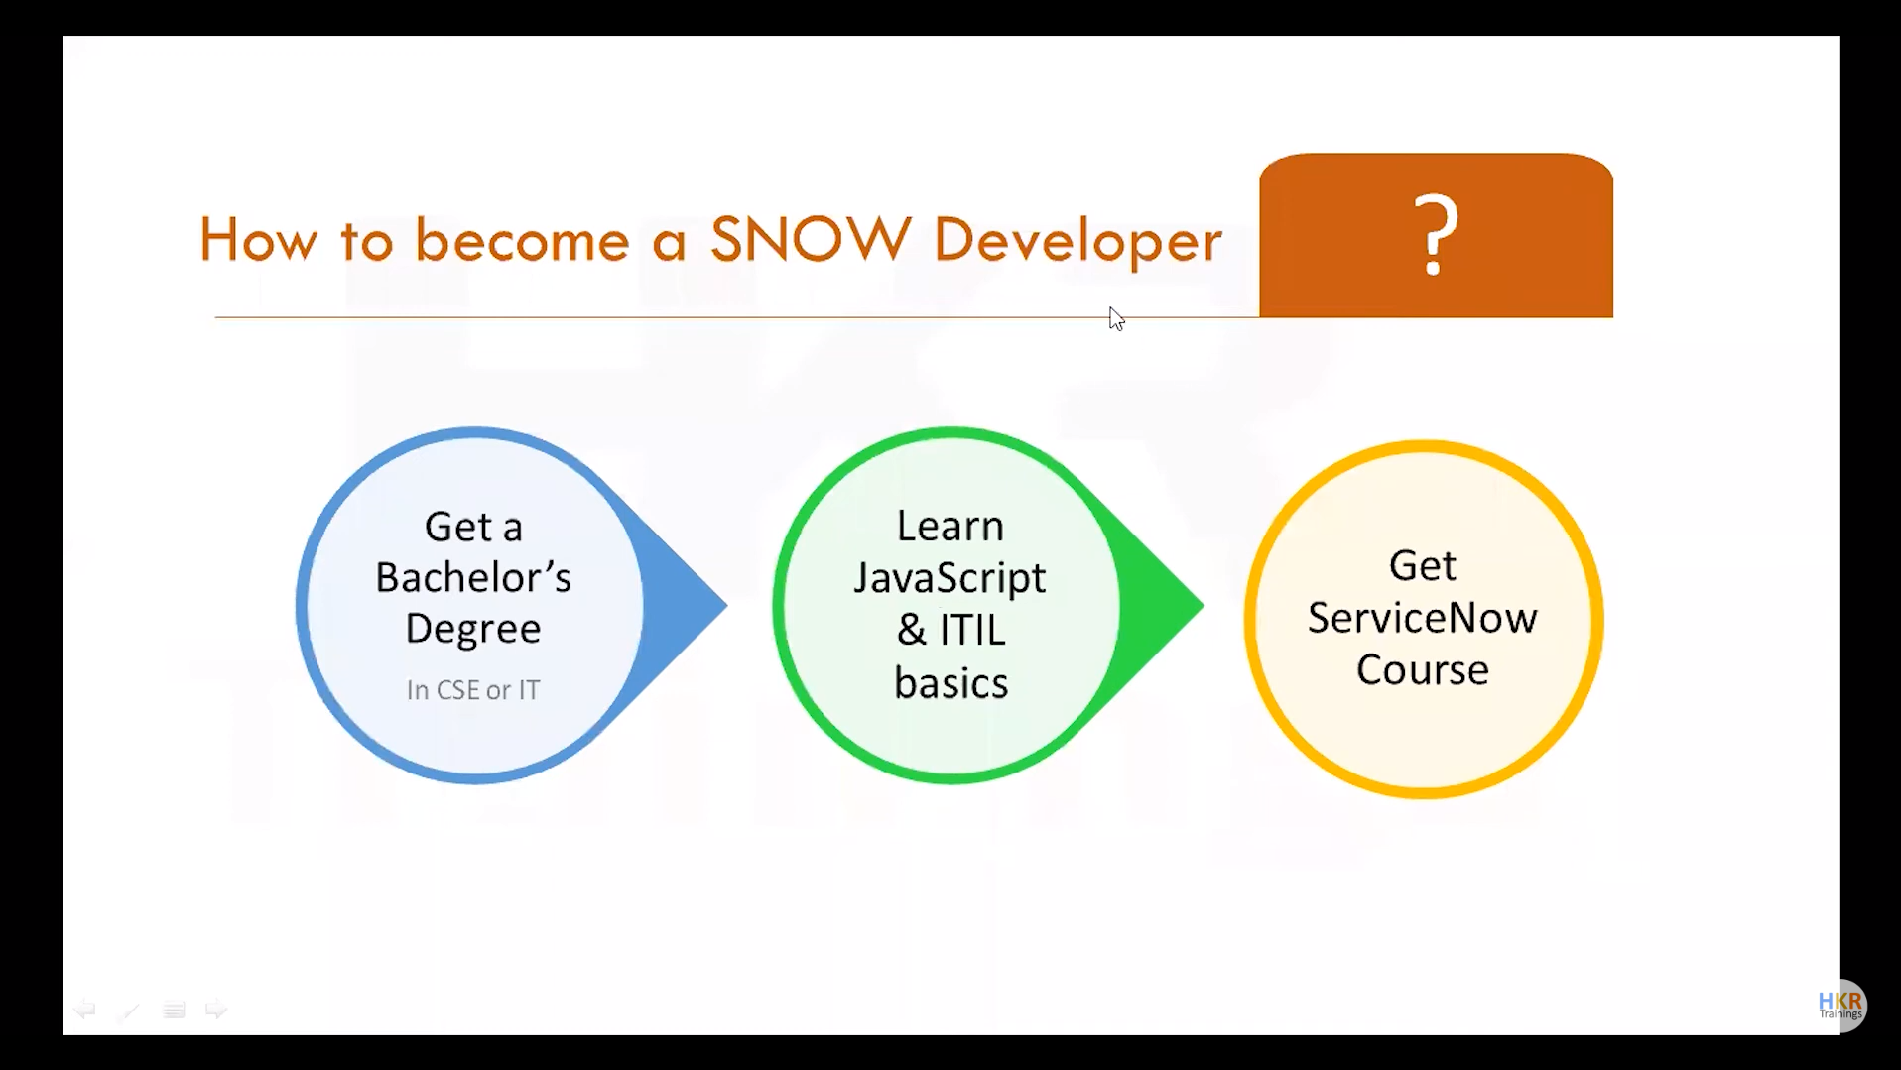

**Career and Growth in ServiceNow** - ServiceNow offers substantial career growth due to its increasing adoption across industries. The platform's no-code environment and comprehensive service offerings make it attractive for organizations, leading to high demand for skilled professionals.

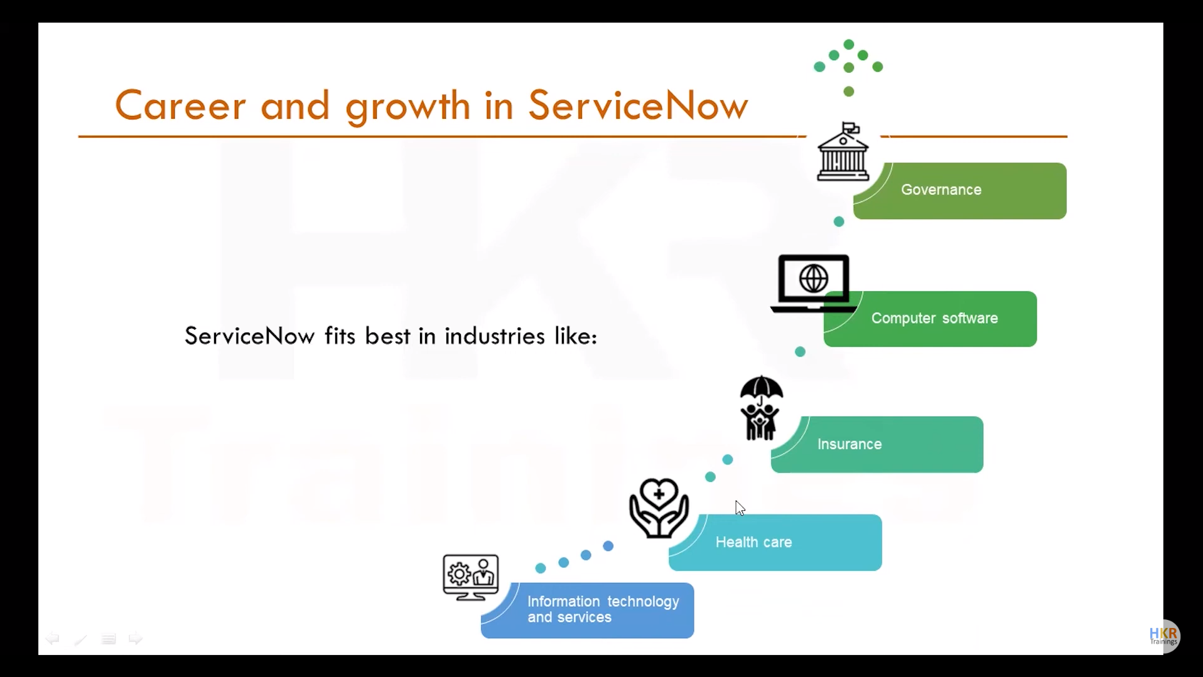

**ServiceNow Certification Training** - Training is available through the ServiceNow learning platform, where users can complete courses to gain foundational knowledge. Certification exams, like the CSA, validate these skills and are essential for career advancement.

**Voucher Code for ServiceNow CSA Exam -** Upon completing certain courses on the ServiceNow learning platform, users can receive free voucher codes for certification exams, such as the CSA, reducing the financial barrier to obtaining these credentials.

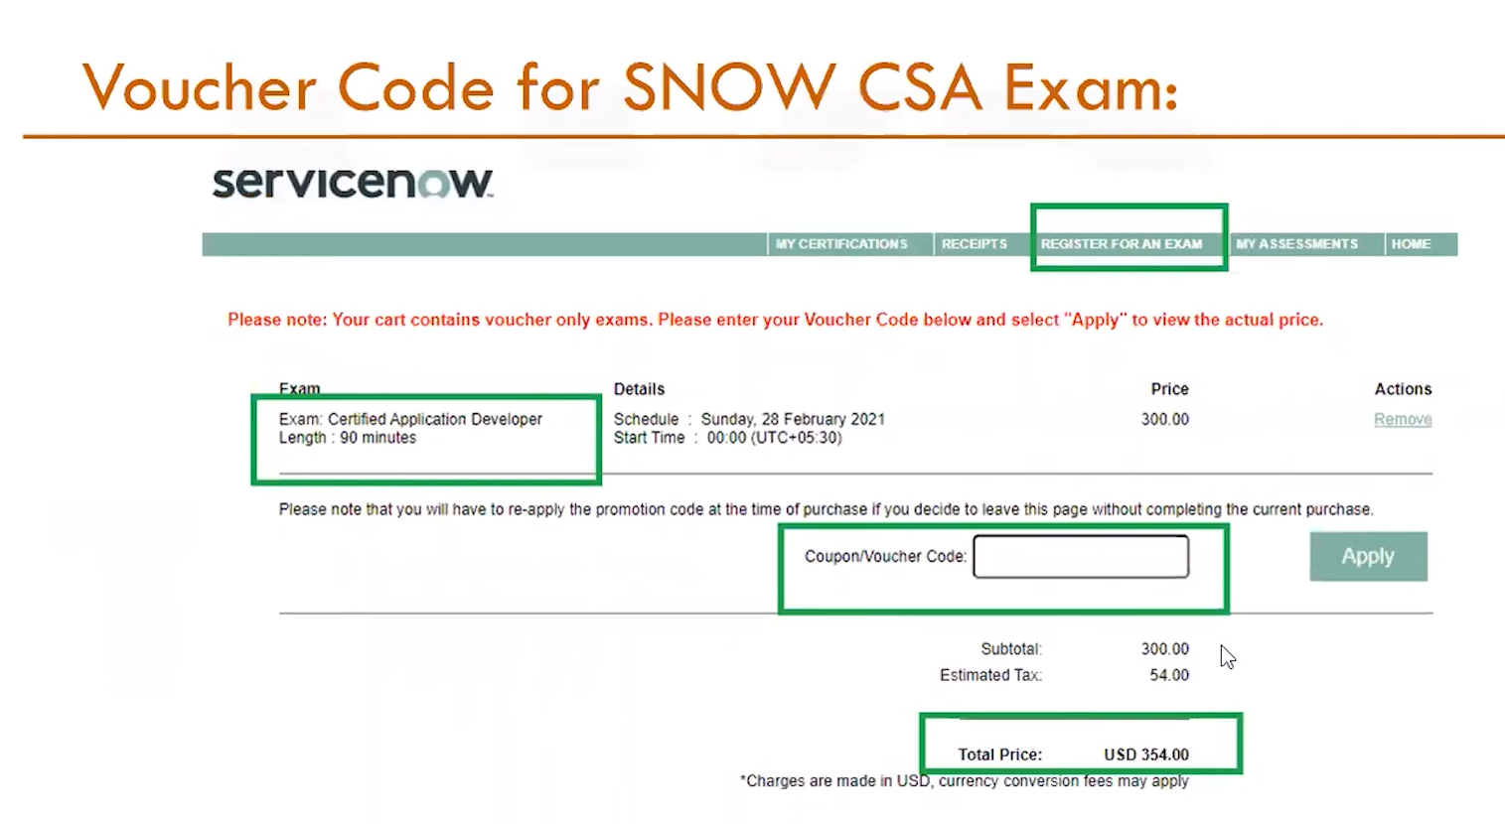

**ServiceNow UI Overview -** The ServiceNow user interface includes the banner frame, content frame, and application navigator. It has evolved to the UI16 design, providing a user-friendly and efficient experience for managing applications and workflows.

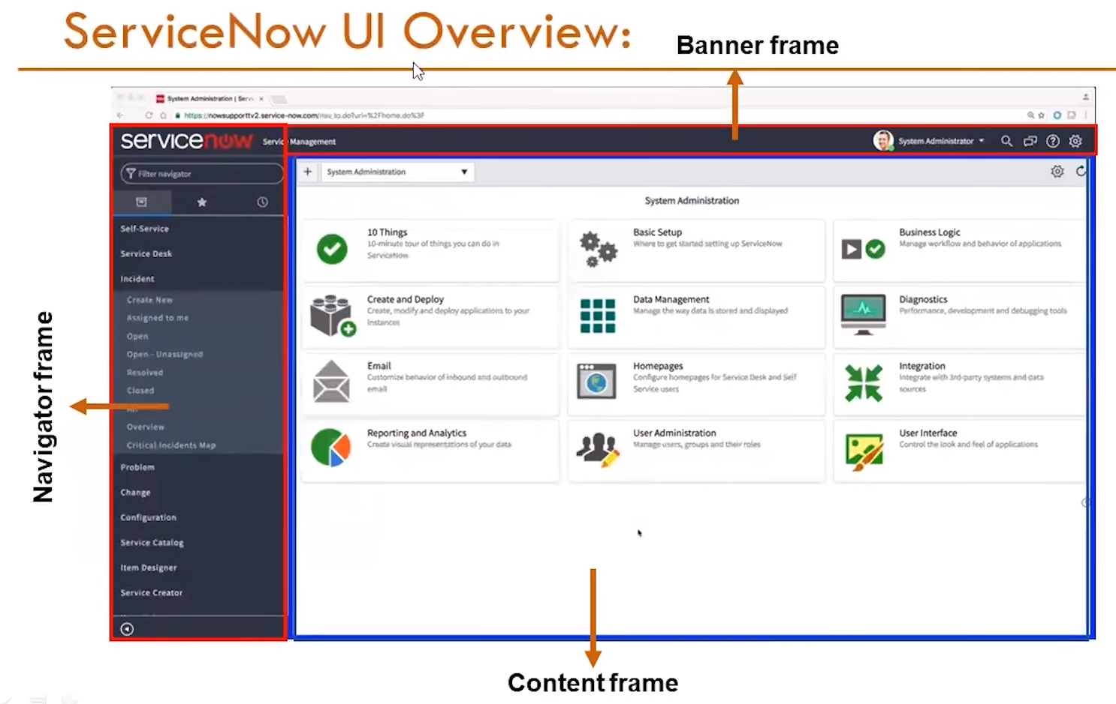

**ServiceNow Components -** Key components include the various modules and elements within the platform, such as lists, forms, and the navigation pane, which together facilitate comprehensive service management.

**Modules -** ServiceNow includes multiple modules like Incident Management, Problem Management, Change Management, HR Management, and more, each serving specific business needs and processes.

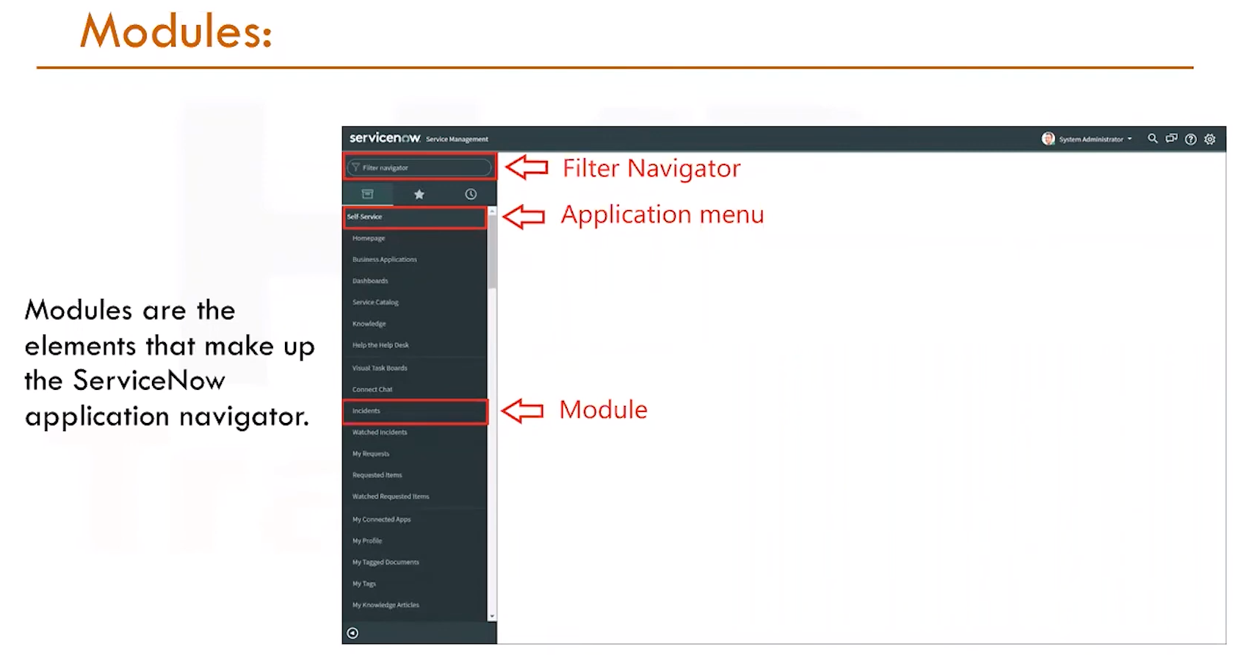

**Incident Module -** This module manages service interruptions by allowing users to create, track, and resolve incident tickets, ensuring minimal disruption to business operations.

**Problem Module -** When incidents occur repeatedly, they are managed as problems. This module helps identify root causes and implement long-term fixes to prevent recurrence.

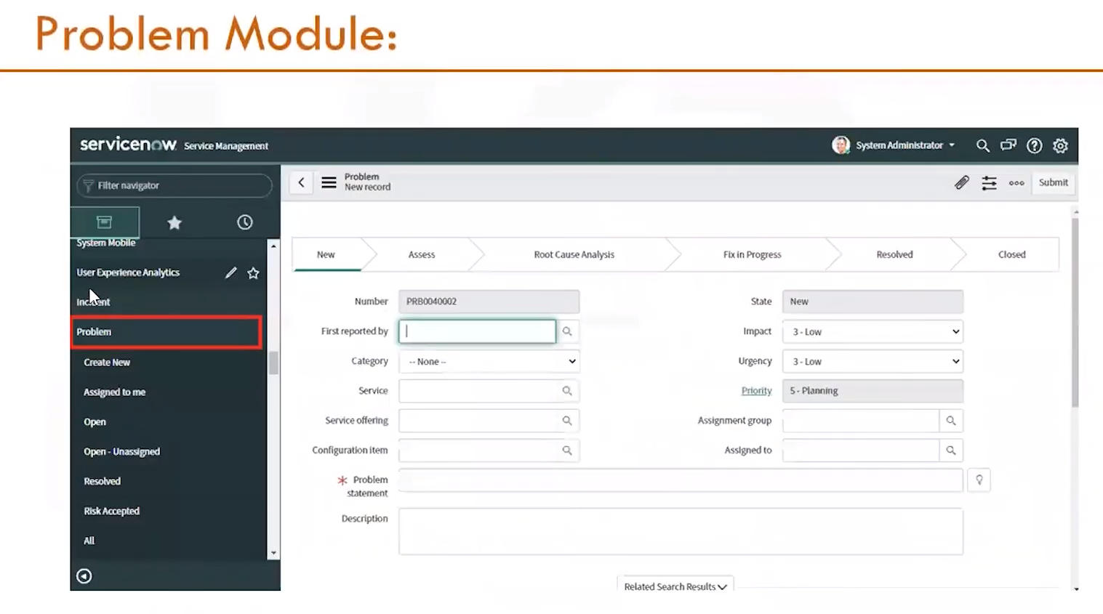

**Change Module -** This module handles system modifications, requiring approvals and ensuring that changes are documented, assessed for risk, and implemented smoothly.

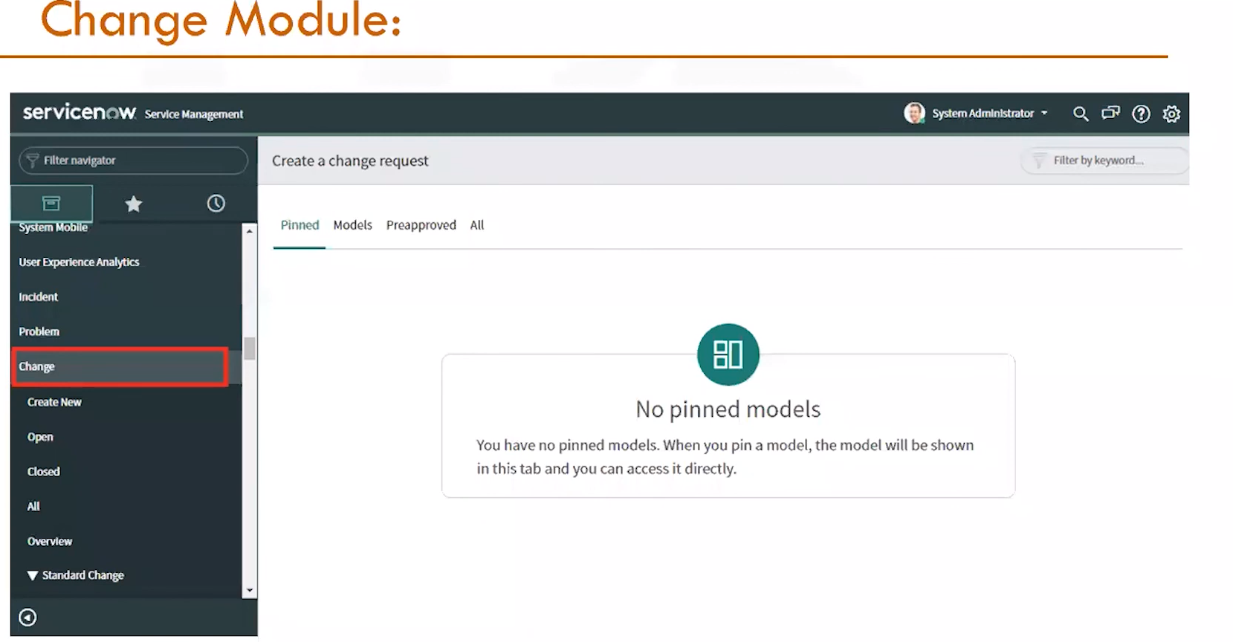

**List -** Lists in ServiceNow display records from tables in a structured format. Users can filter, sort, and personalize these lists to manage data effectively, making it easier to track and analyze information related to various IT services.

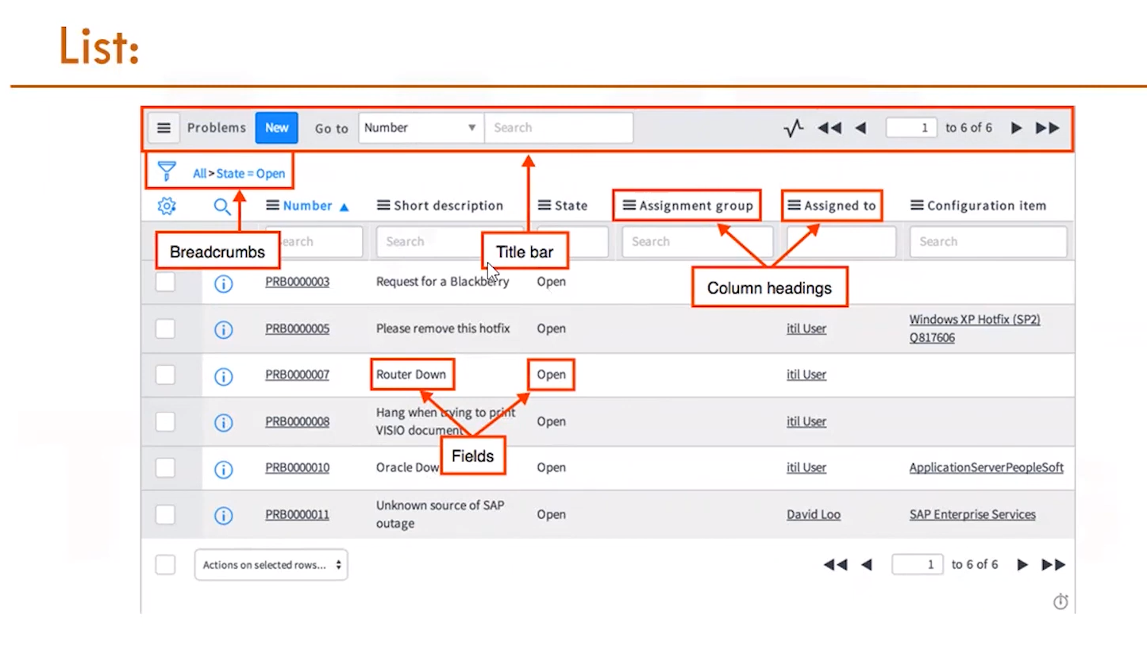

ANANYA CHOUDHARY